The iris dataset has no null values hence it does not require any preprocessing.

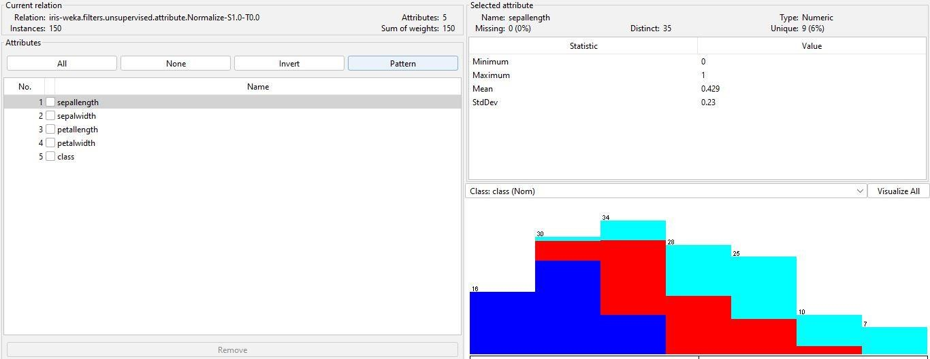

In min-max normalization I normalized every attribute in 0-1 range.

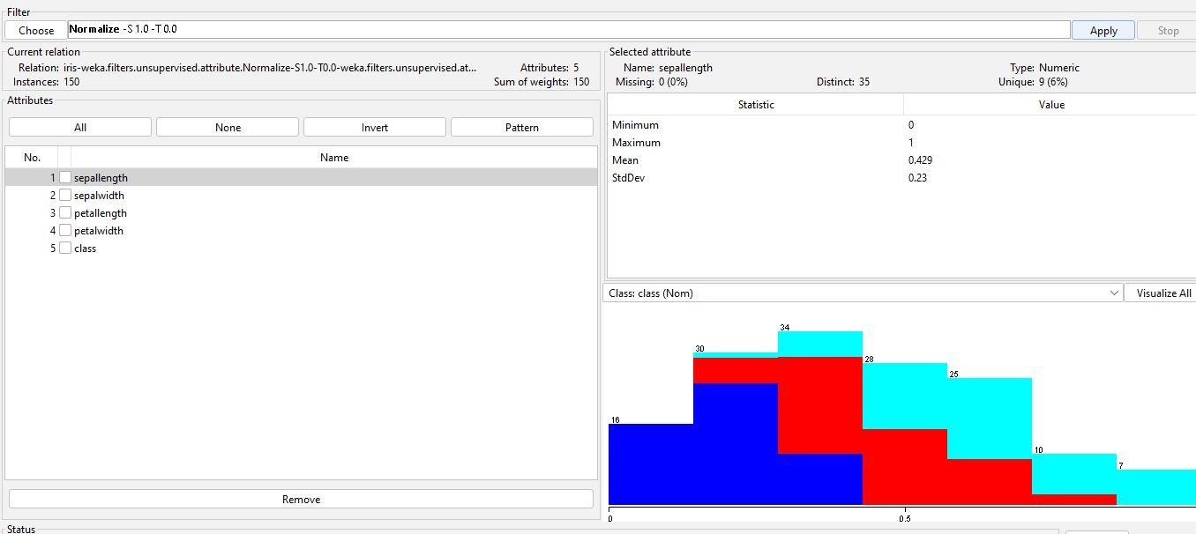

visualizing all attributes.

